AD Synchronization
- Use the another windows server that has nothing installed on it
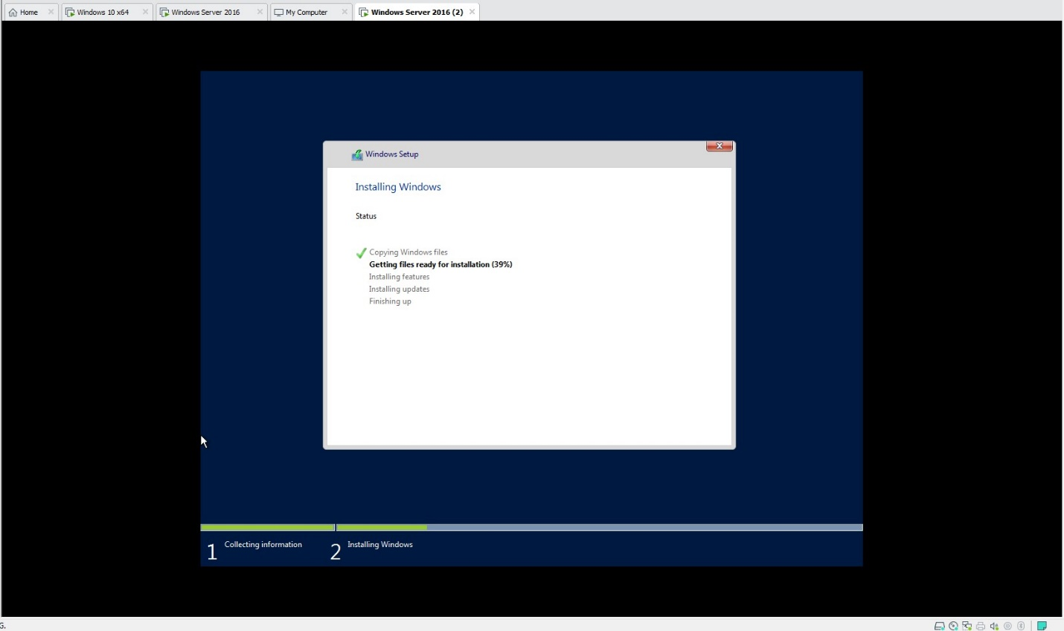
- Install another AD. Ensure your choice reflects that of synchronizing with an already installed domain
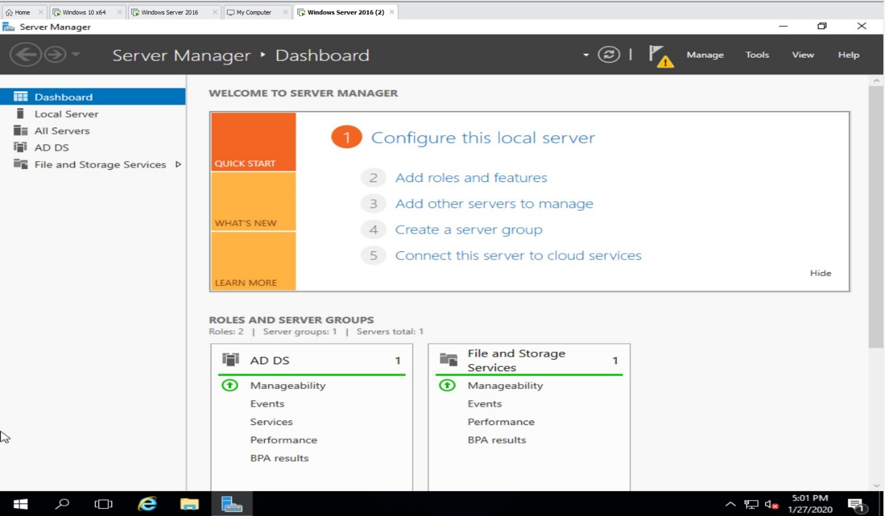
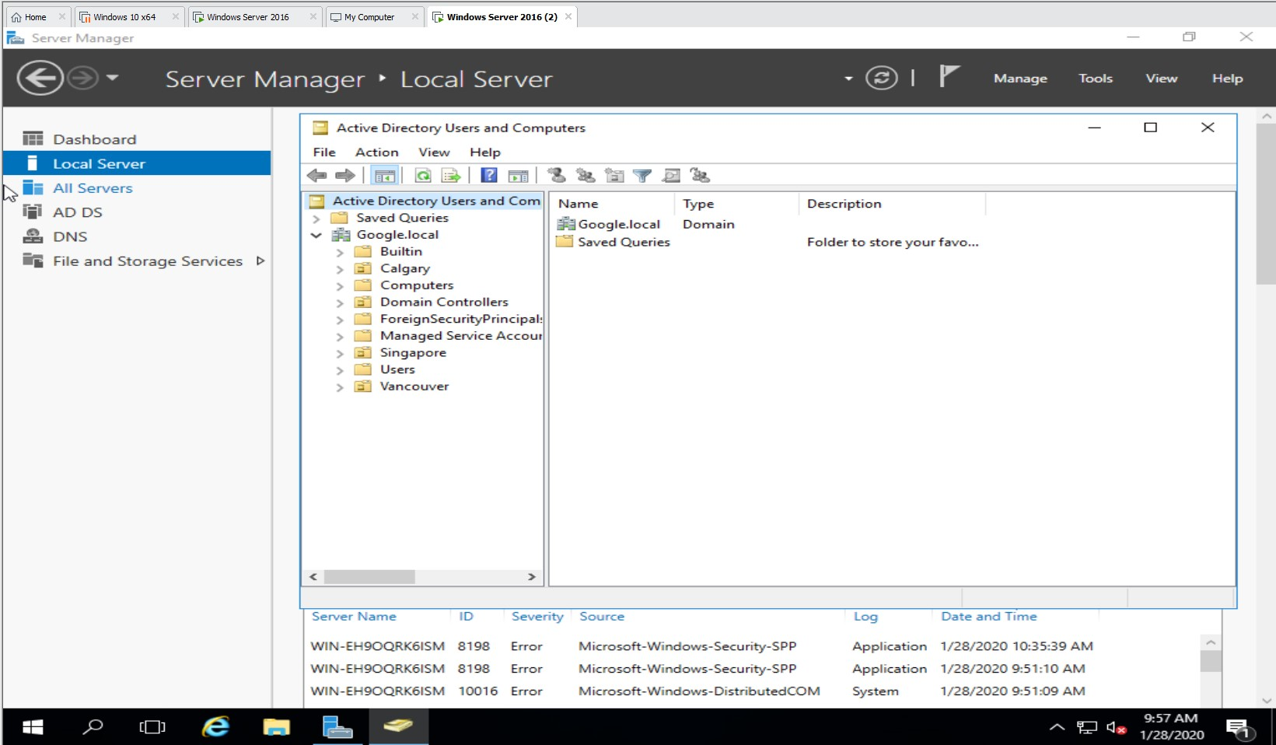
- Once complete, shut down the first AD server
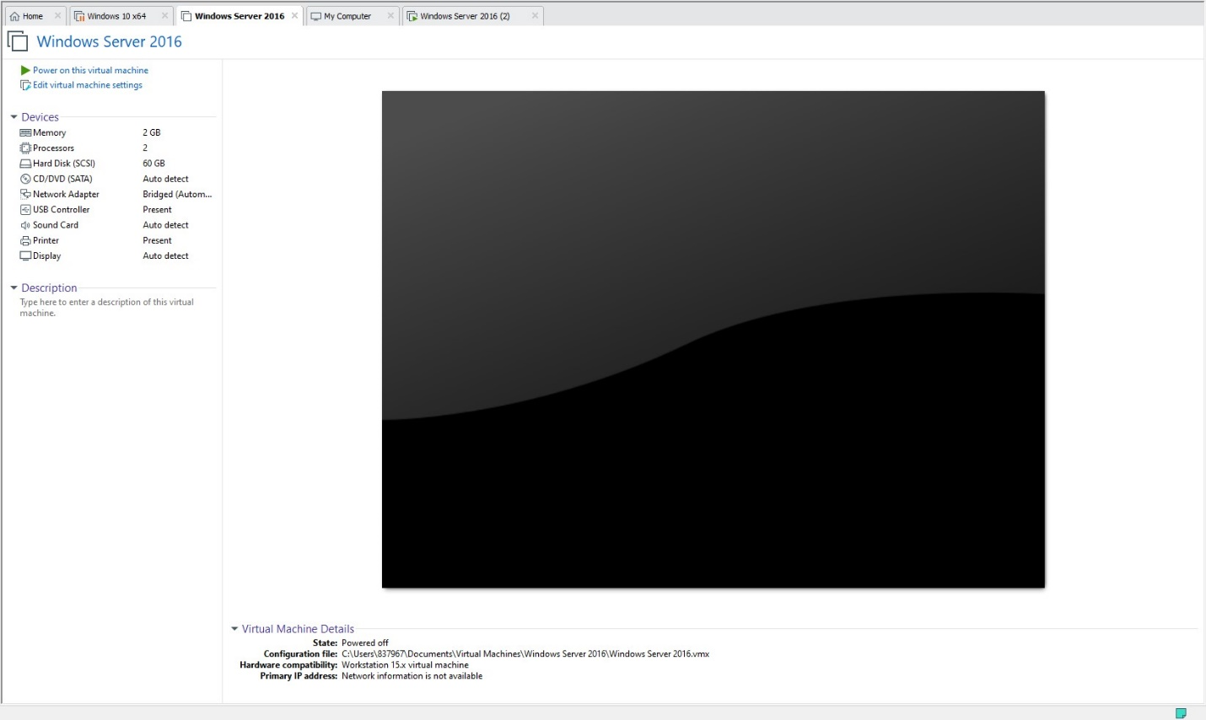
- Login to a workstation with an AD user, what happens?
